
Exceptional Educational Experience
SEND Information Report
Academic Year 2025-26
 | SEND Information Report for Port Isaac Primary Academy  (Aligned with the SEND Code of Practice 2015, updated 2020)

Introduction

- This report explains how Port Isaac Primary Academy, part of Cornwall Education Learning Trust (CELT), supports learners with Special Educational Needs and Disabilities (SEND).
- Our SEND policy is available here
- Cornwall’s Local Offer can be accessed here
- The SEND Code of Practice can be found here

The Four Areas of Need
In line with the SEND Code of Practice, we identify needs within four broad areas:
1. Communication & Interaction
2. Cognition & Learning
3. Social, Emotional and Mental Health (SEMH)
4. Sensory and/or Physical Needs
Area of Need | Description | Relating to difficulties with:
Communication & Interaction | Learners with speech, language and communication needs (SLCN) and or autism spectrum disorder (ASD) may have difficulty in communicating with others. This may be because they have difficulty saying what they want to, understanding what is being said to them or understanding use of social rules of communication. | Attention / Interaction skills:  - May have difficulties ignoring distractions.  - Need reminders to keep attention.  - May need regular prompts to stay on task.  - May need individualised motivation in order to complete tasks.  - Difficulty attending the whole class.  - Interaction will not always be appropriate.  - May have peer relationship difficulties.  - May not be able to initiate or maintain a conversation.  Understanding / Receptive Language:  - May need visual support to understand or process spoken language.  - May need augmented communication systems  - May have frequent misunderstandings.  - Repetition of language and some basic language needs to be used to aid their understanding.  Speech / Expressive Language:  - May use simplified language and limited vocabulary.  - Ideas / conversations may be difficult to follow, with the need to request frequent clarification.  - Some immaturities in the speech sound system.  - Grammar / phonological awareness is still poor and therefore their literacy can be affected.
Cognition and Learning | Support for learning difficulties may be required when learners learn at a slower pace than their peers, even with appropriate scaffolding. This could include areas of need such as Specific learning difficulties (SpLD) eg dyslexia, Moderate learning difficulties (MLD), Severe learning difficulties (SLD) or profound and multiple learning difficulties (PMLD) | - Language, memory and reasoning skills  - Sequencing and organisational skills  - An understanding of numbers  - Problem-solving and concept development skills  - Fine and gross motor skills  - Independent learning skills  - Exercising choice  - Decision making  - Information processing
Social, Emotional, Mental Health (SEMH) | Learners may experience a wide range of social and emotional difficulties which manifest themselves in many ways. These may include becoming withdrawn or isolated, as well as displaying challenging, disruptive or disturbing behaviour. | - Social isolation  - Behaviour difficulties (ODD/EBD/PDA)  - Attention difficulties (ADHD/ADD)  - Anxiety and depression  - Attachment disorders  - Low self esteem  - Issues with self-image  - Emotional based school avoidance (EBSA)
Sensory or Physical | Learners with medical/genetic conditions or physical/sensory impairments. | - Specific medical conditions  - Gross / fine motor skills  - Visual / hearing impairment  - Accessing the curriculum without adaptation  - Physically accessing the building(s) or equipment.  - Over sensitivity to noise / smell / light / touch / taste / Toileting / self-care.

Graduated Approach

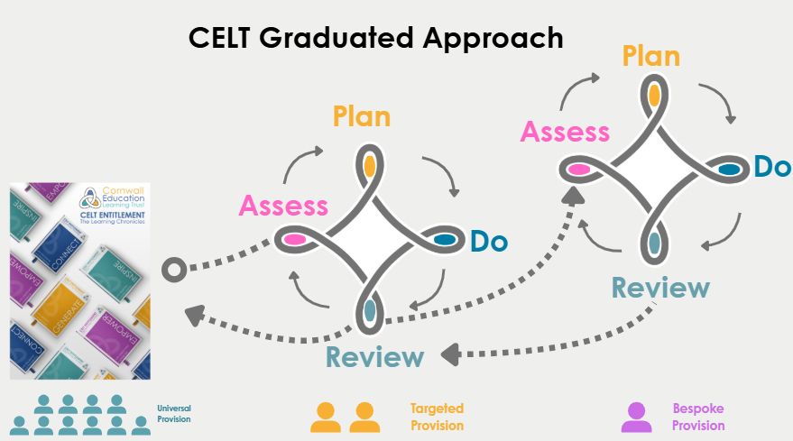

Universal Provision
We provide a wide range of universal provision through our Learning and Teaching Chronicles and use of the Adaptive Teaching Toolkit to meet the needs of all learners. We ensure there is high quality learning and teaching for all learners and that progress and learning is at least good every day. This means the effective inclusion of all learners in high quality everyday personalised teaching is being strived for. Teaching staff have a duty to plan for the needs of all learners. This includes ensuring that any additional adults are used effectively. The school Inclusion team is able to offer specialist expertise and advice to parents, teaching staff and pastoral teams in supporting SEND learners. The Senior Leadership Team and Curriculum Team Leaders monitor and assess the quality of learning and teaching in all classrooms for all learners, including those with SEND.

Teachers will use a range of classroom assessments to identify learners of concern and relevant targets. Teachers then plan to support those learners through adaptive teaching e.g. teacher tweaks and adaptations. Using the adaptive teaching toolkit for support. Additional classroom support/interventions may be implemented. The provision being made for these learners is regularly reviewed as well as their progress.

If concerns persist following a period of teacher adaptations, concerns will be shared with the SENDCO and parents/carers. Additional support/interventions may be planned. The learners progress and any interventions will be monitored and reviewed carefully for impact by class teacher and SENDCO.

Review
Following a review of universal provision and of the learners learning, SEMH or social needs, if concerns persist and the student is requiring support which is additional to and different from standard quality first teaching, they will be moved to targeted provision.

Targeted Provision
Additional in-school assessments may be carried out or referrals may be made to external agencies for assessment and additional support. (assess)
Teacher, parents/carers, learners and SENDCO will set targets and plan relevant provision and interventions. (plan + do)
Targets will be captured in a Student Success Plan (SSP) which will be reviewed termly with parents/carers and learner. (review)

After a review cycle, the SENDCO, parent/carer, learner and class teacher will discuss the impact of the targets. If the targets are required the learner will be added to SEND support register and parents/carers notified and involved in termly reviews

After each cycle is complete, if the learner no longer needs the targeted provision and with the teachers knowing the learners needs, they can receive effective inclusive learning, the learner will be removed from the record of need.

For some learners, targeted provision will not be adequate to enable them to make expected progress towards their targets. Following evidenced cycles of SEND support, the school may apply for an Education, Health and Care Plan. From the agreement to assess, the local authority coordinates an assessment of needs within a 20-week window. The learner, parents/carer and school are fully involved in this process. Needs will be identified, targets set, and plans made for provision to meet these needs.

Once an EHCP has been awarded, the learners will be accessing our bespoke provision of support.

Bespoke provision
These learners will continue to be supported by a student success plan which is reviewed on a termly basis and will have a statutory annual review of their EHCP. A bespoke plan of interventions via internal support or external professionals will be in place and reviewed.

This model ensures that every learner has access to the right support at the right time, and that provision builds on strong classroom practice rather than replacing it.

Assess
  - Baseline collected to show where the learner is
Plan
  - Research informed intervention determined and proposed outcomes.
  - Determine the length of time for intervention
Do
Review
  - Has the learner made progress from when the baseline was collected?
  - Where is the child in comparison to the expected attainment for their age?

Key Questions:

Who is the point of Contact SENDCo? | Point of Contact SENDCo: Ellie Dimmock  Contact details:  Tel: 01208 880494  Email: Primarysend@celtrust.org
What are the specialist SENDCo’s linked to the school? | Communication & Interaction: Ellie Dimmock  Cognition & Learning: Suzanne Le Doux Lucas  Social, Emotional and Mental Health (SEMH): Sarah Kriskovic  Sensory and/or Physical Needs: Karen Dickens
How accessible is the school site? | Description of the School Site - Port Isaac School is a small rural primary  school located in North Cornwall, catering for children from Nursery (age  3) through to Year 6. There are 50 children in total. The main school  building is single-storey, providing ease of access across the site. The only  exception is the Elliott Hut, which is a separate classroom space used for  small group work and interventions. Accessibility Features - The site is  equipped with both internal and external ramps, ensuring that all  classrooms and communal areas within the main building is accessible.  Pathways around the school are level, supporting safe movement for all  individuals.  Adjustments in Place - All areas of the school, apart from the Elliott Hut,  are fully accessible to all pupils, staff, and visitors. Classrooms within the  main building can be reached internally via ramped access, supporting  inclusive use of the school site.  Accessibility Plan: click here
How will school staff support my child? | - A class teacher is the first point of contact for all questions regarding SEND.  - All teachers are responsible for SEND and adapt lessons using the CELT Chronicles and Adaptive Teaching Toolkit  Please see the graduated response for further details. Parents/carers are informed at three times per year via the Assess–Plan–Do–Review cycle.
How will the school identify if my child has SEND? | - Following completion of baseline assessments the results will be analysed by the team as the ‘Assess’ element of the graduated approach.  - From these assessments, it will be identified if they require specific support or provision.  - The team will use the Entry and Exit criteria for CELT SEND along with statutory assessments, staff observations, parent/carer input, and external agency advice.  - Use of the graduated response to monitor progress and decide on additional support.
How are resources allocated and matched to children’s needs? | - CELT schools allocate resources based on learner need, using SEND funding and delegated budgets. We ensure that learners with SEND have their needs met to the best of the school’s ability with the funds available.  - Regular review of provision to ensure resources meet needs.
How will I know how my child is doing? | - Progress evenings, annual reports, SEND Assess Plan Do Review (APDR) meetings with the class teacher.  - Specialist SENDCo meetings can be booked throughout the year.  - Learners with an EHCP: Annual Reviews plus interim reviews with parents/carers. We consider that the parents/carers’ views are a vital part of the review and therefore request parental/carer attendance at the meetings and the completion of parental paperwork prior to the meeting.
How will my child be able to contribute their views? | - We value and celebrate learners being able to express their views on all aspects of school life. Learners are encouraged to share their thoughts with their class teacher, specialist SENDCo and via a range of learner voice activities (surveys, councils, SEND champions and forums).  - Opportunities for involvement in Student Success Plan creation, target setting and review meetings.
What support will there be for my child’s wellbeing? | - All staff receive training to deliver high quality pastoral care. The academy adopts a whole school approach to ensuring that all learners make excellent academic progress and their individual needs are catered for.  - Attendance is rigorously monitored, and support put in place where needed. If attendance falls, you will be contacted by the academies attendance officer and, where necessary, additional support will be implemented to boost attendance.  - The academy is mindful of the need to safeguard the wellbeing of all learners and management of first aid arrangements will be undertaken in such a way as to ensure there is adequate training of staff, provision of first aid equipment and recording of first aid treatment.  - Interventions (e.g. ELSA, nurture groups).  - Where needed, Health Care Plans are overseen by Louise Horwell and shared with staff. Each class teacher has a copy of Health Care Plans.  - Safe/quiet spaces available where possible.
What specialist services are available or accessible? | CELT has an internal inclusion panel where members of the following team can be requested to gain advice / guidance:  - Educational Psychology  - Speech and Language Therapy (SALT)  - Autism Support Service  In addition, we can refer to the local authority’s support for  - Occupational Therapy (OT)  - CAMHS / mental health services  - Cognition and Learning Team  - Specialist Teachers for sensory/physical needs  - Other local authority and voluntary sector services
What training have staff had? | - All teachers trained in Quality First Teaching and use CELT Chronicles and the Adaptive Teaching Toolkit.  - Ongoing SEND CPD delivered across CELT by Specialist SEND Team.  - Learning Support Induction and training programme.  - New staff induction focuses on SEND and adaptive teaching.  - Specialist input from external agencies shared with staff.
How will my child be included in trips and extra-curricular activities? | - Risk assessments include SEND considerations.  - Reasonable adjustments made to ensure participation.  - All clubs and trips are open to all learners in line with suitable risk assessments being carried out.  - Where a learner has a physical/medical need/s, any issues around trips and activities will be discussed in advance and addressed with parents/carers. This includes overnight and residential visits.
How will the school support transition? | For learners transitioning to a new educational phase, we liaise with previous schools/settings and/or  teachers and provide additional transitional support if it is needed. This is arranged on an individual basis and tailored to the needs of the learner/s.  - Extra transition visits, enhanced handovers from previous settings.  - Meetings with specialist SENDCo for new starters with an EHCP.  - Liaison with receiving schools/colleges for Year 3, Y7 and post-16 transition.  - Attendance at EHCP transition reviews.
Who can I contact for more information? | - The class teacher is the first point of contact for concerns.  - If needed they can refer to the specialist SENDCo for support and guidance.  - Complaints: Follow CELT Complaints Policy – Link
How else can we be involved? | We need you to support us by encouraging your child to fully engage with their learning and any interventions offered by:  - Helping them to be organised for their day (including bringing the right equipment and books)  - Above 97% attendance and good punctuality  - Supporting reading at home  - Completion of homework  - Attending progress evenings  - Attending any meetings specifically arranged for your child  - Ensure that any interventions to complete at home are encouraged and supported
What support is there for behaviour, attendance and avoiding exclusion? | As an academy, we have a very positive approach to all types of behaviour with a clear reward and sanction system that is followed by all staff.  Please see our behaviour policy for further information.  Personalised behaviour co-regulation plans where required.  Attendance monitored and support provided if concerns arise.
How is CELT governance involved? | - SENDCo reports to the Headteacher, CELT Community Champions and CELT SEND leads.  - CELT ensures compliance with statutory SEND responsibilities.

